
Faculty of Science

Course: CSCI 2020u – Software System Development & Integration
Component: Assignment
Weight: 10%
Deadline: March 5, 2020 (due by 11:59pm)

Collaboration Policy
You are permitted to work on this assignment in a team, and submit the results as a team. For this sort of assignment, with an open-ended component, the collaboration between multiple team members can be beneficial. Between groups, however, please limit the discussion to the level of general strategy (not code). Groups of size 2 are recommended. Larger groups will be considered with the proviso that the marker will mark your assignment with higher expectations. In any case, be sure that all members of the team fully understand all code, otherwise they will miss intended learning objectives, which may be a considerable disadvantage at exam time.

How to Submit
You will maintain a git repository for this assignment, which is a public repository. To submit the assignment, create a single file ‘README.txt’ that contains instructions on how to download, compile, and run your codes for each question. A .zip, .7z, or .rar file will not be acceptable. Also submit this word file (once you complete) into related drop box on Blackboard before deadline.

Note: Comments are mandatory. Failure to properly document your program will result in a deduction on the marks you receive for this (and any other) assignment.

Remember:
You need to complete this file and submit it in related drop box on Blackboard, in addition to uploading your codes in your git repository, before deadline.

https://github.com/NinjaRow/Assignment-1

Question 1: Displaying Three Cards

Problem Description:
Display a frame that contains three labels. Each label displays a card, as shown in the figure below. The card image files are named 1.png, 2.png, ..., 54.png and stored in the image/card directory. All three cards are distinct and selected randomly.

The image icons can be found in the attached card folder.

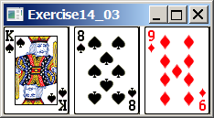

Your Task:
- Create three ImageView and set their icons using the images.
- Display three images from 54 image cards randomly.

Your Code:
Copy-paste your code here:

package sample;
import javafx.application.Application;
import javafx.geometry.Insets;
import javafx.scene.Scene;
import javafx.scene.image.Image;
import javafx.scene.image.ImageView;
import javafx.scene.layout.BorderPane;
import javafx.scene.layout.HBox;
import javafx.stage.Stage;
import java.util.*;
public class Question1 extends Application{
public void start(Stage primaryStage) throws Exception{
//set up and display application panel
BorderPane pane = new BorderPane();
pane.setTop(getHBox());
Scene scene = new Scene(pane);
primaryStage.setScene(scene);
primaryStage.setTitle("Question_1");
primaryStage.show();
}
private HBox getHBox(){
Random rand = new Random();
//set ups spacing/padding/background colour in the hBox
HBox hBox = new HBox(15);
hBox.setPadding(new Insets(15,15,15,15));
hBox.setStyle("-fx-background-color: black");
//generate which card to display
ImageView card1 = new ImageView(new Image("sample/Cards/"+(rand.nextInt(54)+1)+".png"));
ImageView card2 = new ImageView(new Image("sample/Cards/"+(rand.nextInt(54)+1)+".png"));
ImageView card3 = new ImageView(new Image("sample/Cards/"+(rand.nextInt(54)+1)+".png"));
//add the cards to the panel
hBox.getChildren().add(card1);
hBox.getChildren().add(card2);
hBox.getChildren().add(card3);
return hBox;
}
}

Screen shots:
Include two screen shots here:

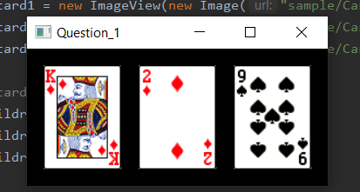
+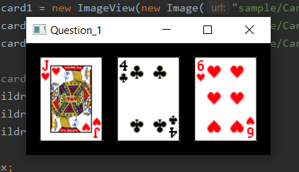

Question 2: Investment-Value calculator

Problem Description:
Write a program that calculates the future value of an investment at a given interest rate for a specified number of years. The formula for the calculation is as follows:

futureValue = investmentAmount * (1 + monthlyInterestRate)years*12

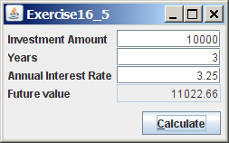

Your Task:
Use text fields for interest rate, investment amount, and years. Display the future amount in a text field when the user clicks the Calculate button, as shown in the figure.

Your Code:
Copy-paste your code here.
package sample;
import javafx.application.Application;
import javafx.geometry.HPos;
import javafx.geometry.Insets;
import javafx.geometry.Pos;
import javafx.scene.Scene;
import javafx.scene.control.Button;
import javafx.scene.control.Label;
import javafx.scene.control.TextField;
import javafx.scene.layout.GridPane;
import javafx.stage.Stage;
public class Question2 extends Application{
//variable initilization
int invAmt;
int year;
float intRate;
public void start(Stage primaryStage) throws Exception {
//gridpane setup
GridPane pane = new GridPane();
pane.setAlignment(Pos.CENTER);
pane.setPadding(new Insets(10,10,10,10));
pane.setVgap(5);
pane.setHgap(5);
//investment label/box
Label invLabel = new Label("Investment Amount:");
TextField IA = new TextField();
IA.setPromptText("Enter Amount");
pane.add(invLabel, 0, 0);
pane.add(IA, 1, 0);
//year label/box
Label yearLabel = new Label("Years:");
TextField years = new TextField();
years.setPromptText("Enter Number of Years");
pane.add(yearLabel, 0, 1);
pane.add(years, 1, 1);
//interest rate label/box
Label intLabel = new Label("Annual Interest Rate:");
TextField AIR = new TextField();
AIR.setPromptText("Enter Interest Rate");
pane.add(intLabel, 0, 2);
pane.add(AIR, 1, 2);
//future value label/box
Label futureValLabel = new Label("Future Value:");
TextField FV = new TextField();
pane.add(futureValLabel, 0, 3);
pane.add(FV, 1, 3);
//calculate button
Button calc = new Button("Calculate");
pane.add(calc, 1,4);
GridPane.setHalignment(calc, HPos.RIGHT);
//display gridpane
Scene scene = new Scene(pane);
primaryStage.setScene(scene);
primaryStage.setTitle("Question_2");
primaryStage.show();
//calculate future value once calculate button is pressed
calc.setOnAction(event -> {
FV.setText(calculate(Integer.parseInt(IA.getText()),Integer.parseInt(years.getText()),Float.parseFloat(AIR.getText())));
});
}
//function to calculate future value
public String calculate(float x, float y, float z){
z=(z/1200)+1;
y=y*12;
return String.valueOf((x*(Math.pow(z, y))));
}
}

Screen shots:
Include two screen shots here:
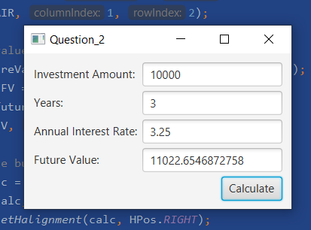
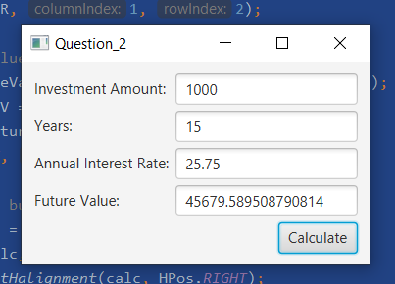

Question 3: Dragging Points on a Circle

Problem Description:
Draw a circle with three random points on the circle. Connect the points to form a triangle. Display the angles in the triangle. Use the mouse to drag a point along the perimeter of the circle. As you drag it, the triangle and angles are redisplayed dynamically.

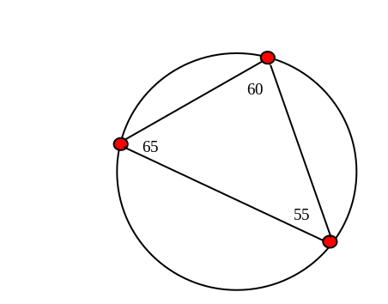

Here is the formula to compute angles:

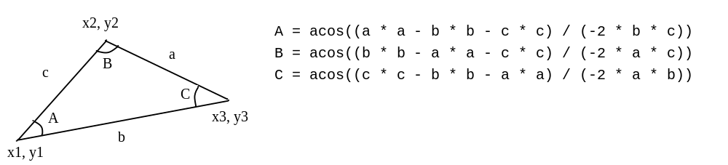

Your Code:
Copy-paste your code here:
package sample;
import javafx.application.Application;
import javafx.scene.Scene;
import javafx.scene.layout.Pane;
import javafx.scene.paint.Color;
import javafx.scene.shape.Circle;
import javafx.scene.shape.Line;
import javafx.scene.text.Text;
import javafx.stage.Stage;
public class Question3 extends Application{
public void start(Stage primaryStage) throws Exception {
//create a pane
Pane pane = new Pane();
pane.setMinSize(300,300);
//generate large circle
Circle circle = new Circle(150,150,120);
circle.setStroke(Color.BLACK);
circle.setFill(Color.WHITE);
//generate the 3 points
Circle point1 = new Circle(150,30,5);
point1.setStroke(Color.BLACK);
point1.setFill(Color.RED);
Circle point2 = new Circle(30,150,5);
point2.setStroke(Color.BLACK);
point2.setFill(Color.RED);
Circle point3 = new Circle(270,150,5);
point3.setStroke(Color.BLACK);
point3.setFill(Color.RED);
//generate connecting lines
Line line1 = new Line(150,30,30,150);
line1.setStroke(Color.GREEN);
Line line2 = new Line(30,150,270,150);
line2.setStroke(Color.BLUE);
Line line3 = new Line(270,150,150,30);
line3.setStroke(Color.PURPLE);
//generate angle text
Text angle1 = new Text(140,50,angle(line2, line1, line3));
Text angle2 = new Text(20,170,angle(line3, line1, line2));
Text angle3 = new Text(260,170,angle(line1, line2, line3));
//add the everything to the panel
pane.getChildren().add(circle);
pane.getChildren().add(line1);
pane.getChildren().add(line2);
pane.getChildren().add(line3);
pane.getChildren().add(angle1);
pane.getChildren().add(angle2);
pane.getChildren().add(angle3);
pane.getChildren().add(point1);
pane.getChildren().add(point2);
pane.getChildren().add(point3);
//action events of moving the points
point1.setOnMouseDragged(e ->{
double dx = e.getX()-150;
double dy = e.getY()-150;
double hyp = Math.sqrt(Math.pow(dx,2)+Math.pow(dy,2));
dx=((dx/hyp)*120)+150;
dy=((dy/hyp)*120)+150;
point1.setCenterX(dx);
point1.setCenterY(dy);
line1.setStartX(dx);
line1.setStartY(dy);
line3.setEndX(dx);
line3.setEndY(dy);
angle1.setX(dx-10);
angle1.setY(dy+20);
angle1.setText(angle(line2, line1, line3));
angle2.setText(angle(line3, line1, line2));
angle3.setText(angle(line1, line2, line3));
});
point2.setOnMouseDragged(e ->{
double dx = e.getX()-150;
double dy = e.getY()-150;
double hyp = Math.sqrt(Math.pow(dx,2)+Math.pow(dy,2));
dx=((dx/hyp)*120)+150;
dy=((dy/hyp)*120)+150;
point2.setCenterX(dx);
point2.setCenterY(dy);
line2.setStartX(dx);
line2.setStartY(dy);
line1.setEndX(dx);
line1.setEndY(dy);
angle2.setX(dx-10);
angle2.setY(dy+20);
angle1.setText(angle(line2, line1, line3));
angle2.setText(angle(line3, line1, line2));
angle3.setText(angle(line1, line2, line3));
});
point3.setOnMouseDragged(e ->{
double dx = e.getX()-150;
double dy = e.getY()-150;
double hyp = Math.sqrt(Math.pow(dx,2)+Math.pow(dy,2));
dx=((dx/hyp)*120)+150;
dy=((dy/hyp)*120)+150;
point3.setCenterX(dx);
point3.setCenterY(dy);
line3.setStartX(dx);
line3.setStartY(dy);
line2.setEndX(dx);
line2.setEndY(dy);
angle3.setX(dx-10);
angle3.setY(dy+20);
angle1.setText(angle(line2, line1, line3));
angle2.setText(angle(line3, line1, line2));
angle3.setText(angle(line1, line2, line3));
});
//display the screen
Scene scene = new Scene(pane);
primaryStage.setScene(scene);
primaryStage.setTitle("Question_3");
primaryStage.show();
}
//function to calculate the angle between 2 lines
public String angle(Line l1, Line l2, Line l3){
double x1 = l1.getEndX()-l1.getStartX();
double y1 = l1.getEndY()-l1.getStartY();
double hyp1 = Math.sqrt(Math.pow(x1,2)+Math.pow(y1,2));
double x2 = l2.getEndX()-l2.getStartX();
double y2 = l2.getEndY()-l2.getStartY();
double hyp2 = Math.sqrt(Math.pow(x2,2)+Math.pow(y2,2));
double x3 = l3.getEndX()-l3.getStartX();
double y3 = l3.getEndY()-l3.getStartY();
double hyp3 = Math.sqrt(Math.pow(x3,2)+Math.pow(y3,2));
double ans = Math.acos((Math.pow(hyp1,2)-Math.pow(hyp2,2)-Math.pow(hyp3,2))/(-2*hyp2*hyp3));
ans = Math.toDegrees(ans);
return String.valueOf(Math.round(ans));
}
}

Screen shots:
Include two screen shots here:
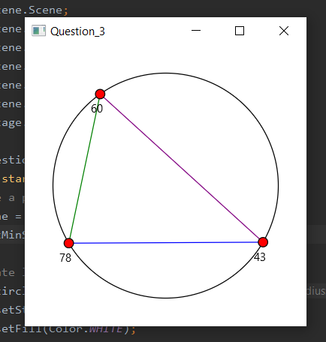
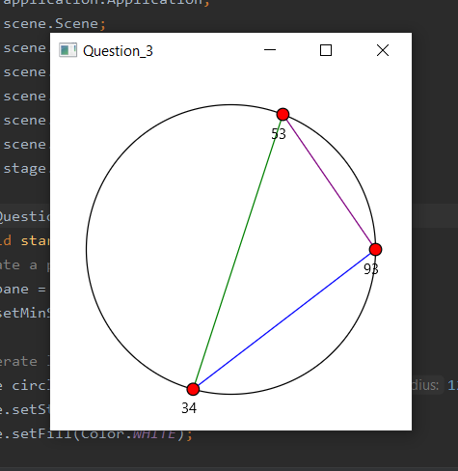
Question 4: Histogram

Problem Description:
Develop a program that displays a histogram to show the occurrences of each letter in a text area. The histogram should show the occurrences of each letter in a text file, as shown in the following figure. Assume that the letters are not case sensitive.

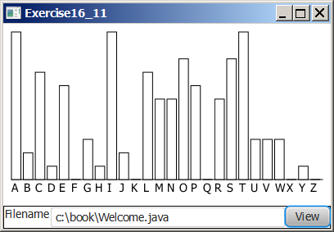

Your Task:
- Place a pane that will display the histogram in the center of the frame.
- Place a label and a text field in a panel, and put the panel in the south side of the frame. The text file will be entered from this text field.
- Pressing the Enter key on the text field causes the program to count the occurrences of each letter and display the count in a histogram.

Your Code:
Copy-paste your code here:

//Rowan Birnbaum 100701879
package sample;
import javafx.application.Application;
import javafx.event.ActionEvent;
import javafx.event.EventHandler;
import javafx.geometry.Pos;
import javafx.scene.Scene;
import javafx.scene.chart.BarChart;
import javafx.scene.chart.CategoryAxis;
import javafx.scene.chart.NumberAxis;
import javafx.scene.chart.XYChart;
import javafx.scene.control.Button;
import javafx.scene.control.TextField;
import javafx.scene.layout.StackPane;
import javafx.scene.layout.VBox;
import javafx.stage.Stage;
import java.io.*;
public class Question4 extends Application {
//graph setup
CategoryAxis AxisX = new CategoryAxis();
NumberAxis AxisY = new NumberAxis();
BarChart<String,Number> chart = new BarChart<>(AxisX,AxisY);
public XYChart.Series dataSeries = new XYChart.Series();
public char[] alphabet = "ABCDEFGHIJKLMNOPQRSTUVWXYZ".toCharArray();
public int count[] = new int[256];
//function to add number of times each letter occurred to the data set
public void graph(){
int x = 97;
for (int i=0; i<alphabet.length; i++){
// process ascii array element as numbers of letters within the text file
dataSeries.getData().add(new XYChart.Data(Character.toString(alphabet[i]), count[x]));
x++;
}
}
public void start(Stage stage) throws Exception {
// create the pane
StackPane bgPane = new StackPane();
// create button and textfield for file directory
Button view = new Button("View");
view.setAlignment(Pos.CENTER);
TextField dir = new TextField("Enter directory");
dir.setAlignment(Pos.BOTTOM_CENTER);
dir.setMaxWidth(200);
// set axis labels
AxisX.setLabel("Alphabet");
AxisY.setLabel("Appearance of letter");
graph();
// event handler for button and enter key
EventHandler<ActionEvent> createGraph = new EventHandler<ActionEvent>() {
public void handle(ActionEvent e) {
// reset count array every time button or enter is pushed
count = new int[256];
FileInputStream file = null;
try {
// get file directory
file = new FileInputStream(dir.getText());
} catch (FileNotFoundException exception) {
exception.printStackTrace();
}
// set up a reader function to read strings in text file
BufferedReader reader = new BufferedReader(new InputStreamReader(file));
String line = null;
try {
line = reader.readLine();
} catch (IOException ex) {
ex.printStackTrace();
}
String line1;
// loop through each line of the file until there are no more lines
while (line != null) {
// get the length of line for for loops and turn to lower case
int len = line.length();
line1 = line.toLowerCase();
// Initialize count array index
for (int i = 0; i < len; i++)
count[line1.charAt(i)]++;
try {
line = reader.readLine();
} catch (IOException exception) {
exception.printStackTrace();
}
}
graph();
}
};
// when button pressed
view.setOnAction(createGraph);
dir.setOnAction(createGraph);
//add xyzchart to bar-graph
chart.getData().addAll(dataSeries);
VBox vBox = new VBox();
vBox.getChildren().addAll(dir, view, chart);
// set vbox to pane
bgPane.getChildren().add(vBox);
Scene scene = new Scene(bgPane, 850, 850);
stage.setTitle("Question_4");
stage.setScene(scene);
stage.show();
}
}

Screen shots:
Include two screen shots here:
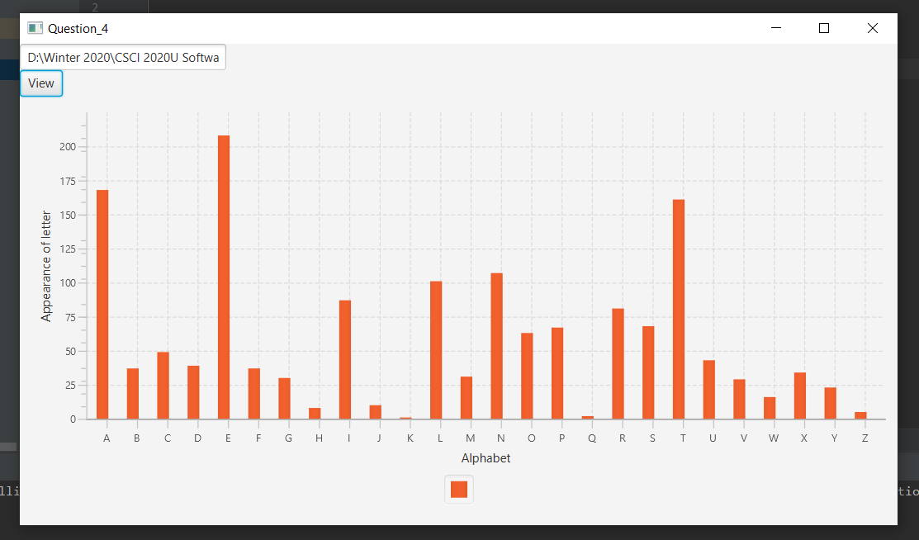

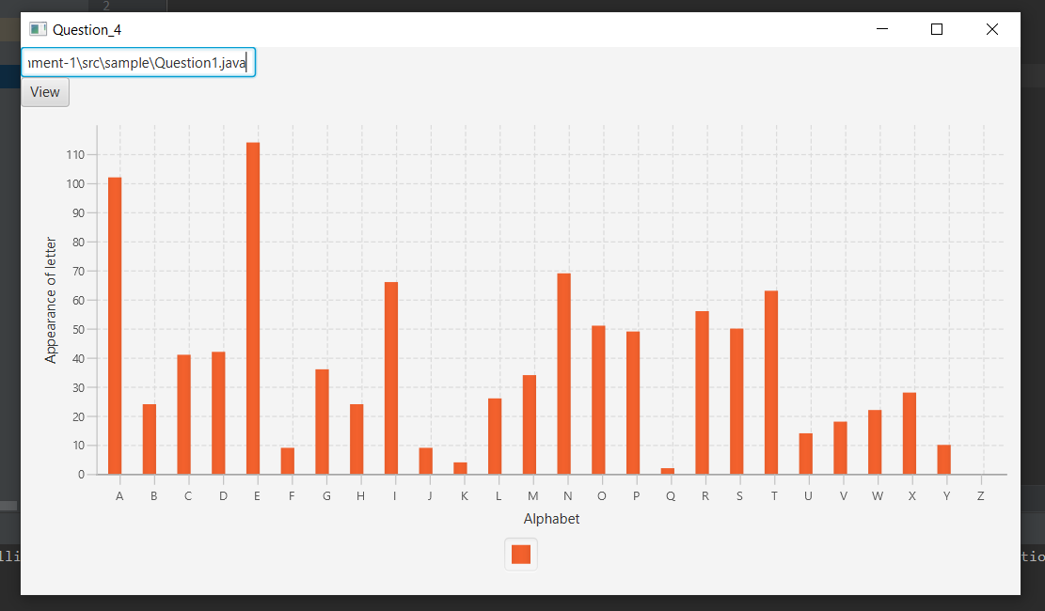
Remember:

You need to complete this file and submit it in related drop box on Blackboard, in addition to uploading your codes in your git repository, before deadline.

